Legend
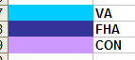

The following excel spreadsheet foreclosure tracking board 2014.xls, illustrates actions that need to be taken after we foreclose.

FHA

*1st legal: date that attorneys posted at the courthouse prior to foreclosure, this info resides in MS
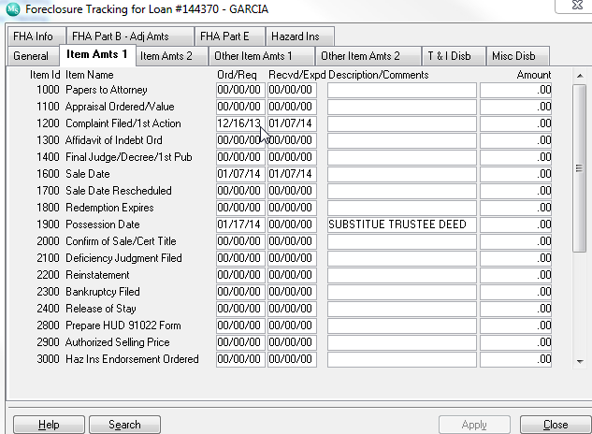
Metric: pick duedate and 1st legal needs to come in 5 months after due date if this is not the case we need to change color or provide an alert that first legal is beyond due date

*UPB:Unpaid Principal Balance, if foreclosre not final we pick the info from the ‘current principal balance” if paid off or foreclosed then we pick amount from “principal paid”

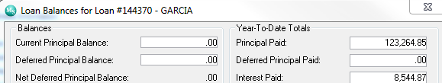

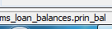
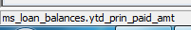

If loan is paid off principal = 0 then go to investor/service fee
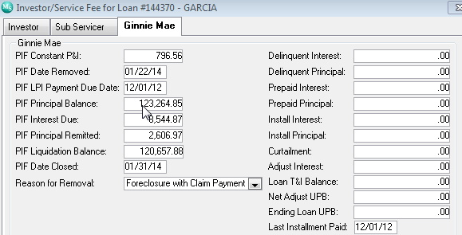

*F/C DATE
Date Foreclosed
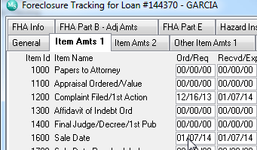
Line 1600 sale date ord/req
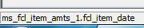

*INSPECTION ORDERED: inspection after foreclosured to see if property is occupy or vacant.

Information will come from memo’s
We are selecting type: pi-conveyance inspection
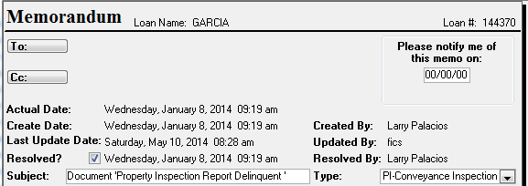

Metric: Inspection needs to be order a day after foreclosure

*Eviction: If prop still occupy we need to vacate property in order for Hud to take over and convey
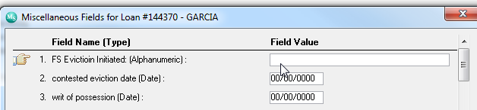
It is a misc field
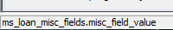

This is the order where we need to populate this date:
- fs eviction initiated misc field

*Writ of possession ordered: court order to tell customer to have borrower vacate property

*Eviction Stop: when we start process and borrower just leaves so we need to stop process of eviction
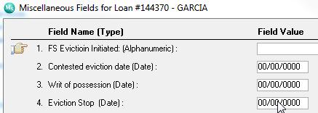

*Eviction Completed:
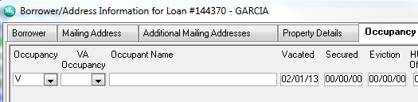
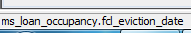

Metric: Eviction completed needs to be 45 or less from foreclosure if not , we need to bring over contested date.

*Conveyance Package Received date
If property is vacant , Russell(property preservation rep) provides the conveyance package ( cleaning of property, lock securing before and after photos, and repairs needed)
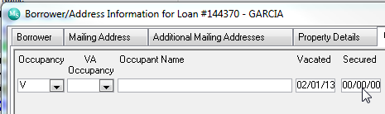
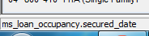

- Possesion Date
The date of foreclose D recorded and or 1st vacancy
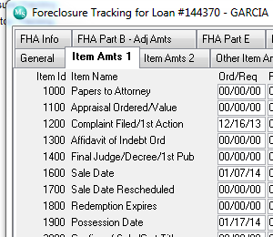
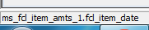
Item 1900 , ord req
*Conveyance (30days from possession)

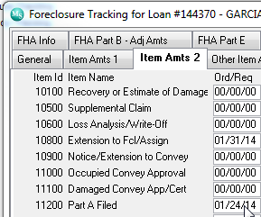
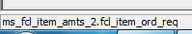
Metric: Possession date + 30 days calendar

*HUD Advice of Payment Part A

When we get paid by hud our conveyance

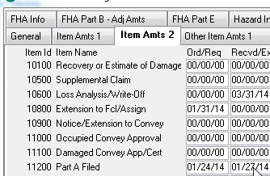

*Payment Amount Part A

The amount we got paid
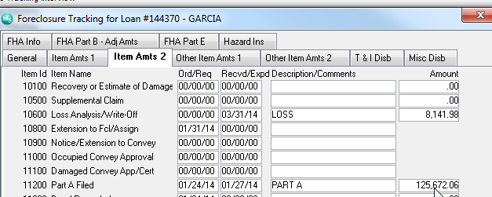

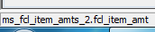

*Title Package
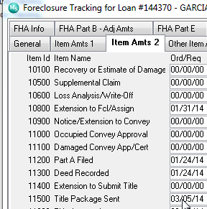

*Title Approval (45 days from Conveyance)
HUD approving the title property and given us okay to do part b
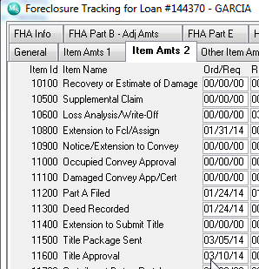

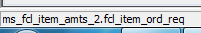

Metric the time from part a filed to title package send needs to be 45 days otherwise we need to have an alert 5 days prior so that foreclosre does not missed date

*Claim

Claim for losses for attorneys fees, eviction , repairs , insurance etc..

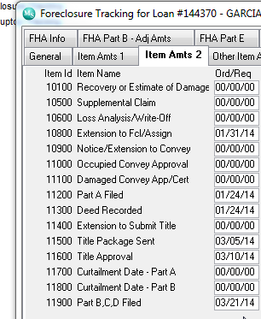

15 days from title approval is this date, again we need to be notified 5 days prior for us to acknowledge and notify

- HUD Advice of payment letter B : Date we got paid

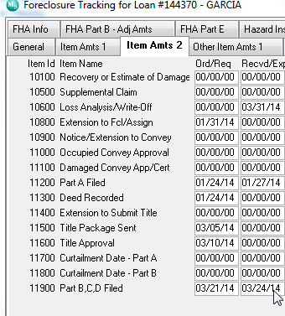
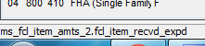

*Claim Payment Amount of part b





